Customer Segmentation Data for Marketing Analysis

Project Overview
This project analyses customer demographic and purchasing behaviour data to understand customer segments, buying patterns, and revenue contribution. The goal is to support data-driven marketing strategies using interactive dashboards.

Tools Used
- Python (Data cleaning & preprocessing)
- PostgreSQL (Data storage & SQL analysis)
- Power BI (Dashboard creation & visualization)

What Is Covered
- Total customers vs target
- Total revenue vs target
- Average purchase frequency analysis
- Customer distribution by age group and gender
- Category-wise purchase frequency
- Revenue contribution by product category
- Customer spending behaviour and income analysis
- Membership duration vs purchase frequency
- Monthly sales performance and growth trends

Dashboard Details
- Customer Segmentation Overview
- Age Group & Gender Analysis
- Category Preference Analysis
- Revenue & Purchase Frequency KPIs
- Customer Spending Pattern Visualization
Dashboard Features
- Interactive KPI cards
- Age group, gender, and category slicers
- Target vs actual performance tracking
- Clean and business-focused visual layout

Customer Segmentation Data for Marketing Analysis Dashboard
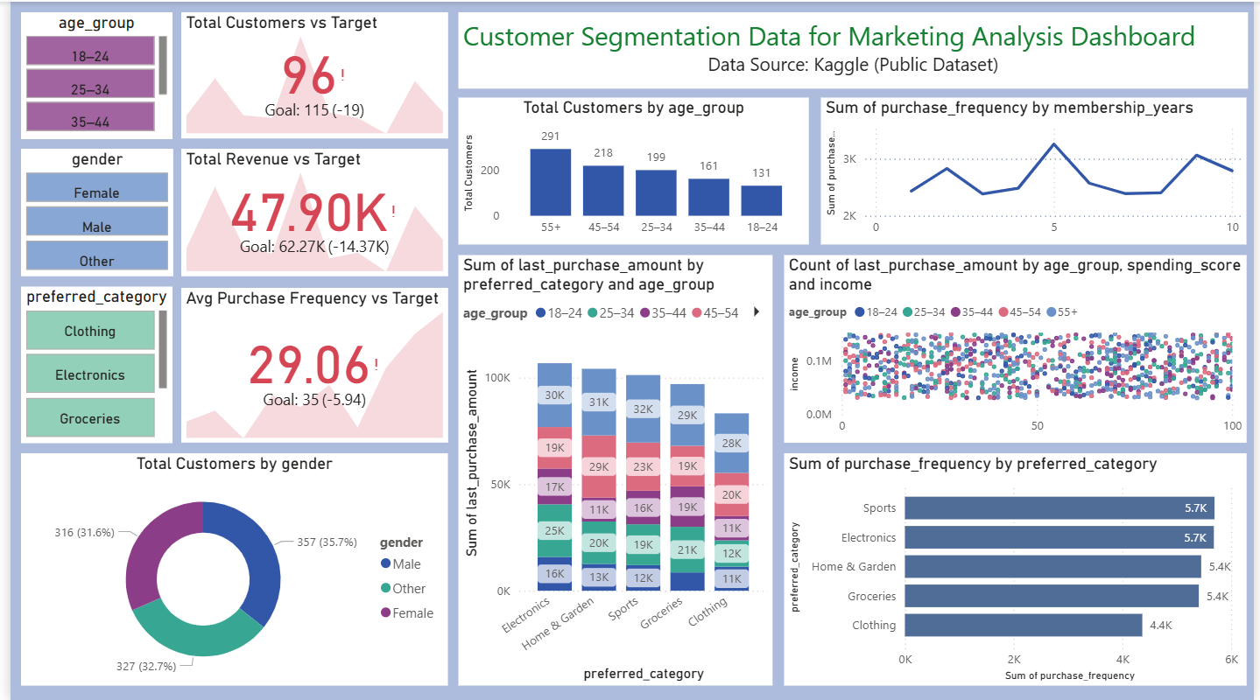

Customer Segmentation Analysis: Male Customers Aged 55+
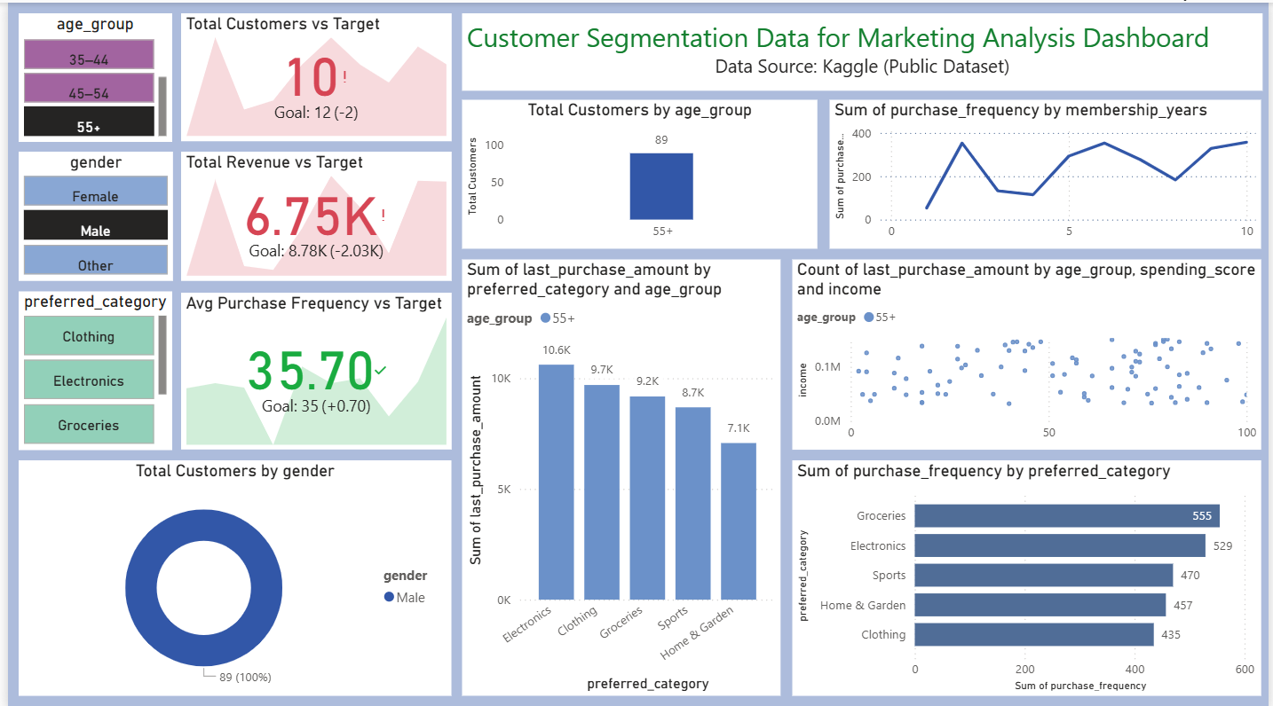

Groceries Purchasing Analysis: Male Customers Aged 25–34
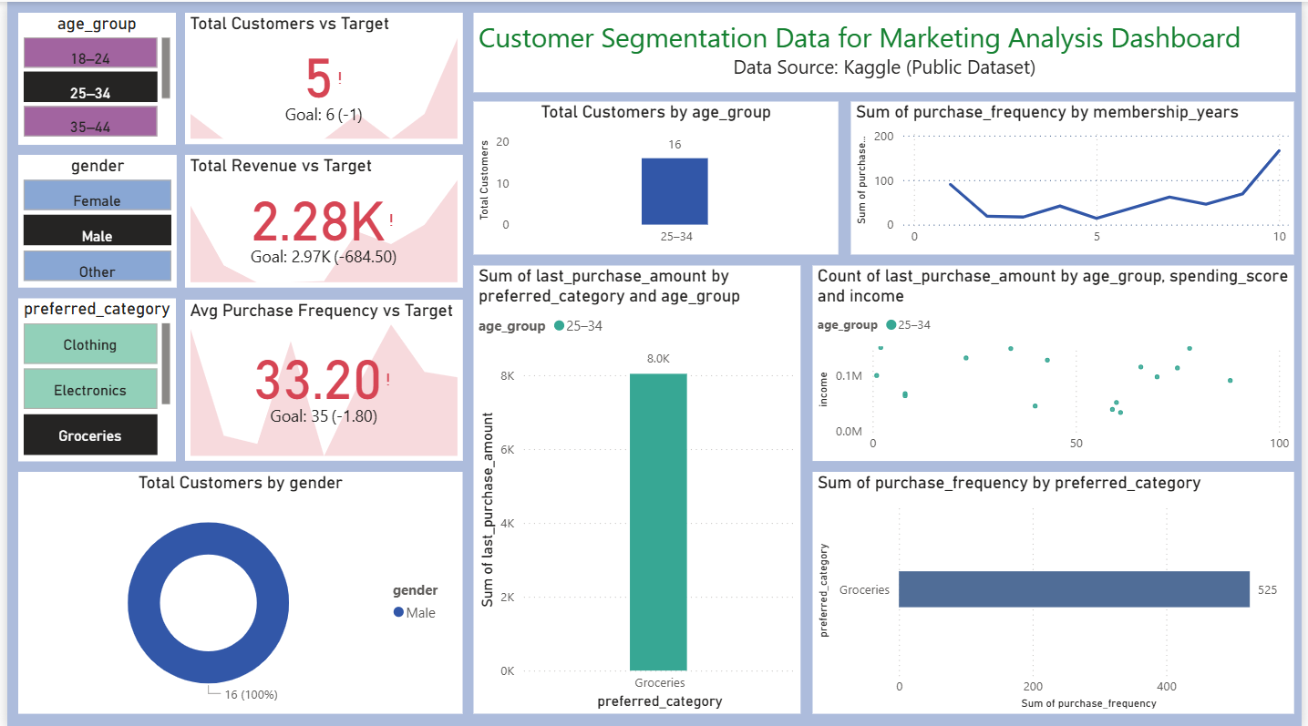

Sales & Engagement Insights: 18–24 Sports Segment
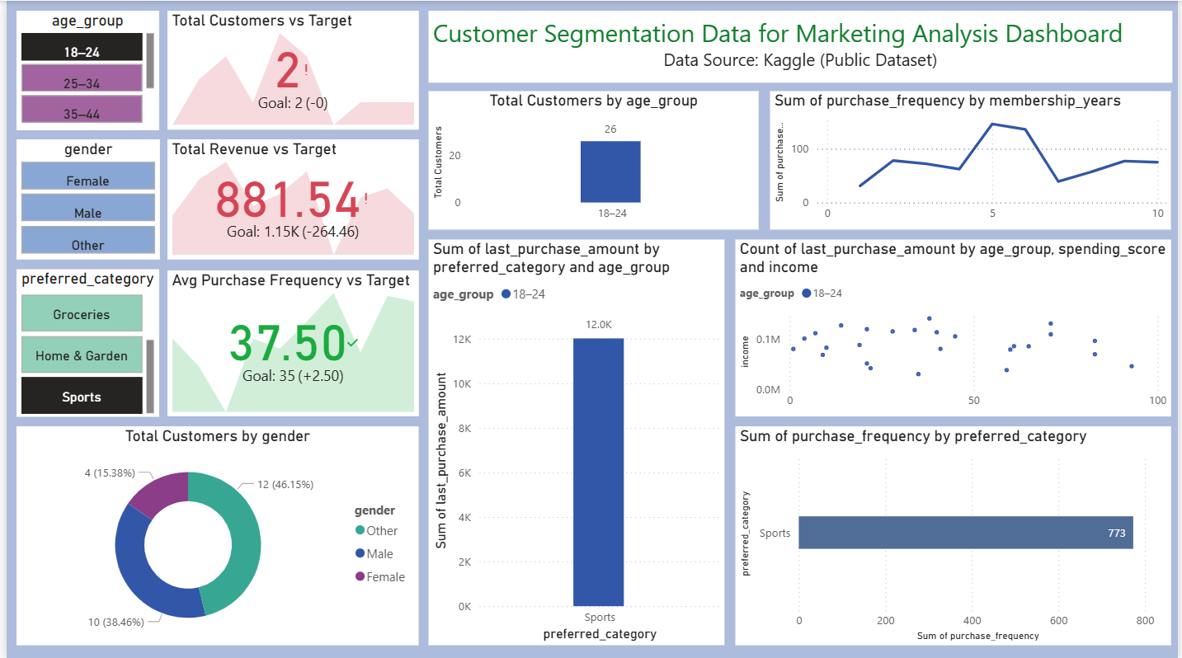

Sales & Engagement Insights: Female 55+ Electronics Segment
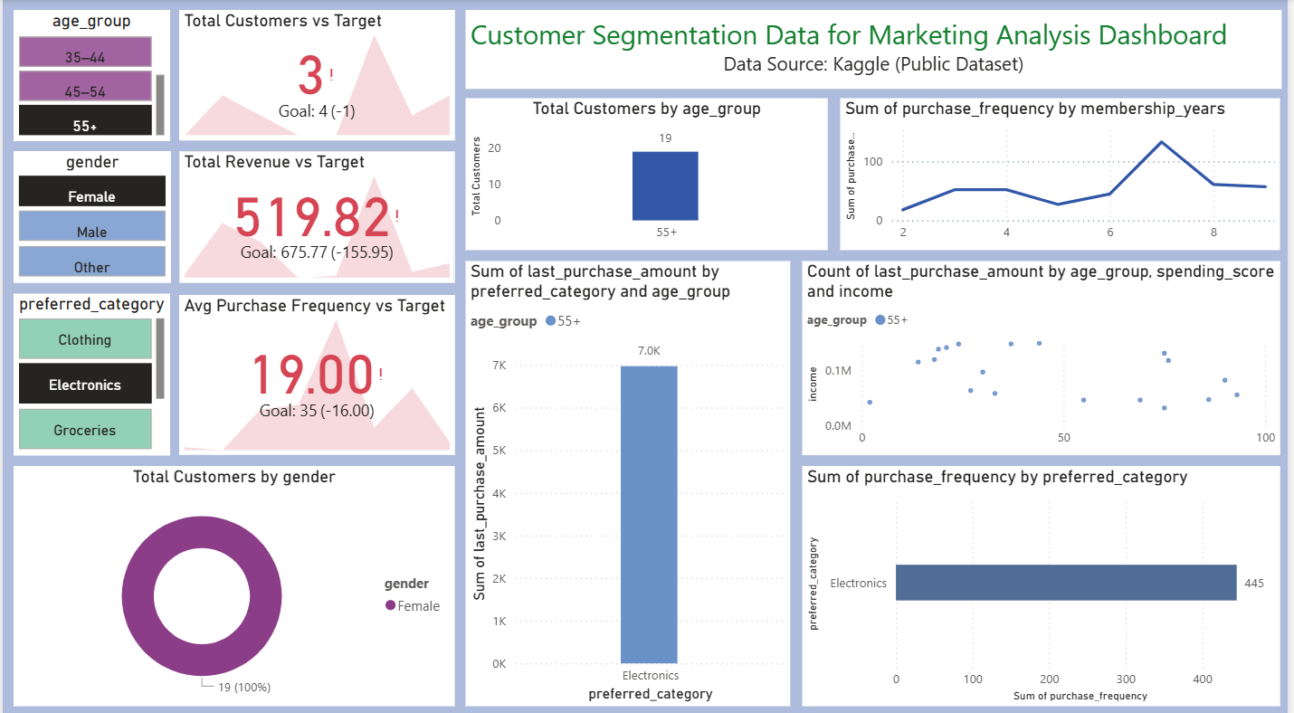

SQL Sales Summary & Customer Insights
Customer Retention Rate (%)
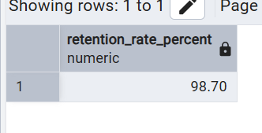
Revenue Contribution by Category (%)
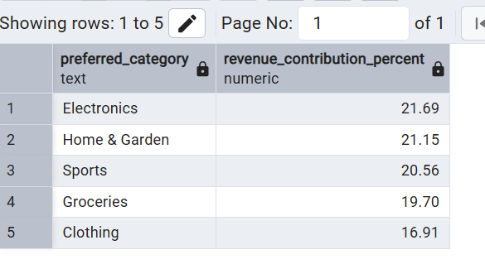
Average Purchase Amount by Age Group
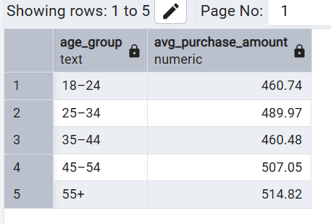
Customer Retention Risk Segment
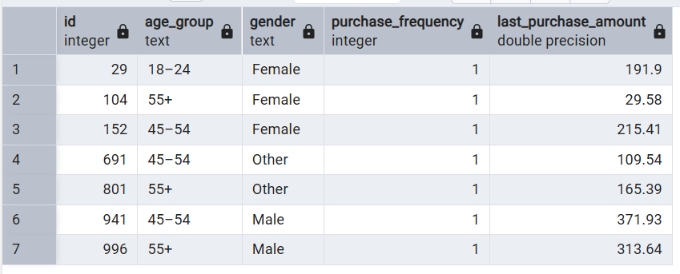

Key Observations
- Older age groups contribute higher customer counts
- Electronics and Sports categories show higher purchase frequency
- Purchase frequency varies with membership duration
- Revenue and purchase targets are not fully met, indicating growth opportunities
- Customer spending behaviour shows diverse income-level distribution

Data Source
Kaggle (Public Dataset)

Author
Sunit Manna
Python • PostgreSQL • Power BI

Project Purpose
This project aims to help marketing and business teams identify high-value customer segments, understand purchasing behaviour, and optimize marketing strategies using data-driven insights.

